Experiment-7
Name: Mithun Raj D Rollno:240701315

Experiment with different design structures and colour palettes for the application and Gather user feedback.

WireFrame Designs with difference color palettes:
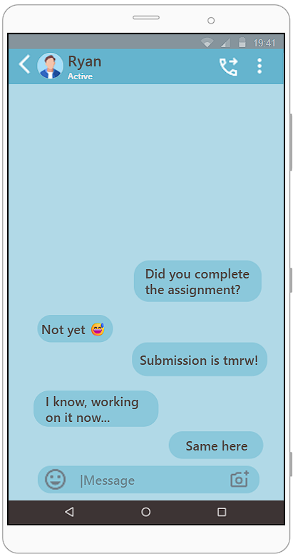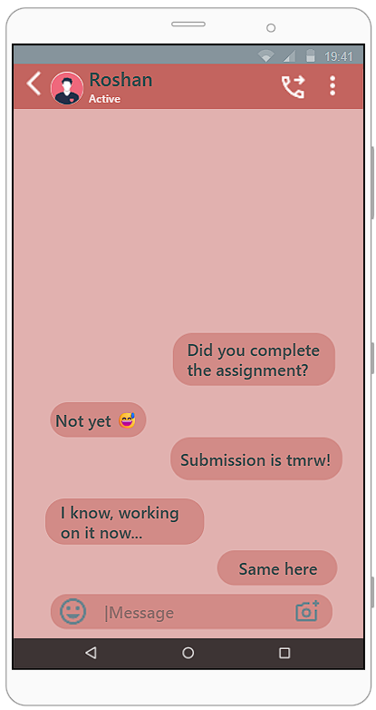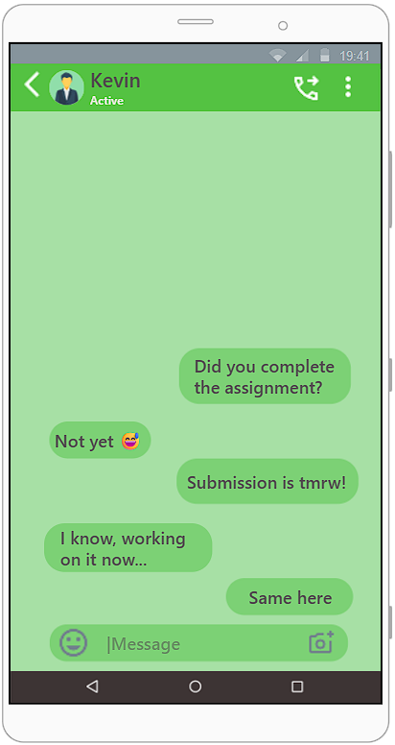

🔵 Blue Theme (Ryan Chat)
This version uses a blue color theme, which feels calm and clean. The layout is exactly the same as the red one, with a header, chat bubbles, and input field. The softer blue shades make the messages easier to read and more comfortable for the eyes. Overall, this design gives a more professional and relaxed chatting experience.

🔴 Red Theme (Roshan Chat)
This wireframe shows a chat screen with a warm red color style. The top bar has the user’s name, profile picture, and active status. The chat messages are arranged in bubbles on both sides, making the conversation easy to follow. The red theme gives an energetic and bold feel, but it might feel a bit strong for long usage. At the bottom, there is a message box with emoji and camera options for interaction.
🟢 Green Theme (Kevin Chat)
This wireframe uses a green color scheme, similar to popular messaging apps. It feels natural and familiar to users. The chat layout remains the same, with clear message bubbles and a simple input area. The green theme is easy on the eyes and gives a friendly and balanced look.

Google form link:
https://forms.gle/SmcAbmrPmVH4zS1h9
User Feedback Collection
- A Google Form was created to collect user feedback on the chat app design.
- The form was shared with users to evaluate different color themes and layouts.
- Users were asked to give their rating on visual appeal, readability, and overall experience.

